**RandomPageRedirect Testing Documentation**

**What It Tests:**

Ensures that seeding a specific value will always return the same url for page redirects.

**Why It Tests:**

The underlying RNG needs to be tested to ensure that numbers are generated by giving a seed.

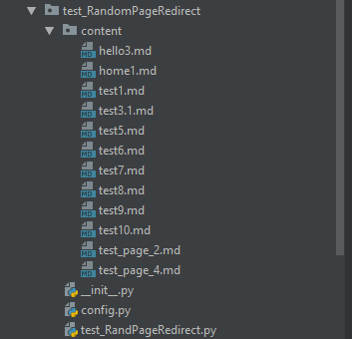

File Structure for RandomPageRedirect testing

The content directory is used for putting sample pages that are usually interpreted by the wiki system. These will not change so make testing consistent.

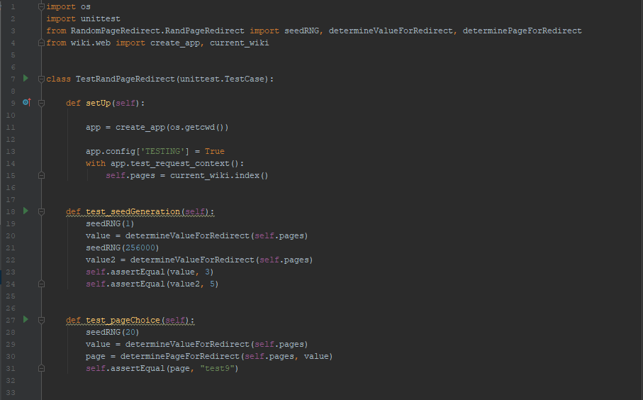



Testing File

The Setup file calls create_app passing in the current working directory. The wiki.web app is being setup. Testing config is set to true. The pages in that directory are loaded.

The first test method seeds the RNG to a value of 1 and 256000 respectively and asserting that the page generated will be consistent.

The second test method seeds the RNG again this time to 20, determines the value for redirect and assures that the actual page traversed to is correct.